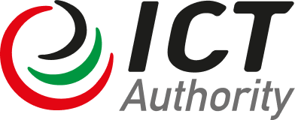

KENYA DIGITAL ECONOMY ACCELERATION PROJECT
P170941

SOCIAL ASSESSMENT

JUNE 2023

Table of Contents
Table of Contents 2
Acronyms 4
Acknowledgment 7
1.0 Introduction 8
1.1 Project Description 8
1.2 Project Beneficiaries 14
1.3 Implementation Arrangements 14
2.0 The Social Assessment 16
2.1 Justification for the Social Assessment 16
2.2 Objectives of the Social Assessment 16
3.0 Methodology 17
3.1 Sampling of Counties and VMGs 17
3.2 Methods 17
3.2.1 Literature and Documents Review 17
3.2.2 Focus Group Discussions 18
3.2.3 Key Informant Interviews 18
3.2.4 Data Analysis 19
4.0 Key Findings of the Social Assessment 20
4.1 Socio-economic Profile of the Study Area 20
4.1.1 Overview of Nakuru County Demographic Characteristics 20
4.1.2 Land Ownership and Landlessness 20
4.1.3 VMG Livelihoods and the Digital Economy 21
4.1.3.1 Ogiek of Nassuit, Marioshoni 21
4.1.3.1.1 Ogiek Participation in the Digital Economy 21
4.1.3.2 The Maai-Mahiu Masai 22
4.1.3.2.1 The Maai-Mahiu Masai and the Digital Economy 23
4.1.3.3 Masai, Samburu and Turkana of Kongasis, Ol Jorai 24
4.1.3.3.1 Masai, Samburu and Turkana of Kongasis, Ol Jorai and the Digital Economy 24
4.1.4 Impact of COVID-19 on VMGs 25
4.2 Policy, Institutional and Legal Frameworks 25
4.3 Stakeholder and Institutional Analysis 27
4.3.1 Farmers’ Groups 27
4.3.2 Cooperative Societies 27
4.3.3 Pastoralist Groups 27
4.3.4 County Government 27
4.3.5 National Government 28
4.3.6 Indigenous Leaderships 28
4.3.7 Civil Society Organizations 28
4.3.8 Teachers’ Associations and Unions 28
5.0 Potential Positive and Negative Impacts of the KDEAP 29
5.1 Potential Positive Impacts 29
5.2 Potential Negative Impacts 29
6.0 Enhancement of Potential KDEAP Benefits For VMGs 31
7.0 Capacity Building and Institutional Strengthening 32
8.0 Grievance Redress Mechanism 34
9.0. Conclusions 37
References 38
Annexes 39
Annex 1: Attendance Sheet for the Nassuit FGD for Ogiek People 39
Annex 2: Attendance Sheet for the Mai Mahiu Masai FGD 40
Annex 3: Attendance Sheet for the FGD of Ol Jorai VMGs 41
Annex 4: LIST OF PEOPLE LIVING WITH DISABILITIES CONSULTED 42
Annex 5: List of Key Informants Interviewed 43
Annex 6: FGD Guide 44
Annex 7: Key Informant Interview Guide 46

Acronyms
ACA | Athi Catchment Area
AfDB | African Development Bank
AMRO | Avoid, Minimize, Restore & Offset
CA | Communications Authority
CAPEX | Capital Expenditure
CBC | Competency Based Curriculum
CERC | Contingent Emergency Response Component
C-ESMP | Contractor Environmental and Social Management Plan
CIH | Constituency Innovation Hubs
CO₂ | Carbon Dioxide
COVID-19 | Coronavirus Disease-2019
CPS | Country Partnership Strategy
DE4A | Digital Economy for Africa Initiative
DLP | Digital Literacy Program
DOSHS | Directorate of Occupational Safety and Health Services
ECOP | Environmental Code of Practice
EHPMP | Environmental Health and Pollution Management Program
EHSG | Environment, Health and Safety Guidelines
ELC | Environment and Land Court
EMCA | Environment Management and Coordination Act
ENNCA | Ewaso Ng’iro North Catchment Area
EPRP | Emergency Preparedness and Response Plan
ERS | Economic Recovery Strategy
ESA | Environmental and Social Assessment
ESIA | Environmental and Social Impact Assessments
ESF | Environmental and Social Framework
ESMF | Environmental and Social Management Framework
ESMP | Environmental and Social Management Plans
ESSs | Environmental and Social Standards
ESRS | Environment and Social Review
FTTH | Fiber to the Home
FY | Financial Year
GBV | Gender Based Violence
GCCN | Government Common Core Network
GCRF | Global Crisis Response Framework
GDP | Gross Domestic Product
GHG | Greenhouse Gases
GIIP | Good International Industry Practice
GoK | Government of Kenya
GRS | Grievance Redress Service
IBRD | International Bank for Reconstruction and Development
ICT | Information and Communication Technologies
ICTA | Information Communications Technology Authority
IDA | International Development Association
IDP | Internally Displaced Persons
IFMIS | Information Management Systems for Tax, Financial management
INDC | Intended Nationally Determined Contributions
IP | Internet Protocol
IPF | Investment Project Financing
ISP | Internet Service Provider
IP/SSAHUTLCs | Indigenous Peoples/Sub-Saharan African Historically Underserved Traditional Local Communities
ITES | Information Technology Enabled Services
ITU | International Telecommunication Union
IUCN | International Union for Conservation of Nature
KeBS | Kenya Bureau of Standards
KDEAP | Kenya Digital Economy Acceleration Program
KENET | Kenya Education Network
KEPSA | Kenya Private Sector Alliance
KFS | Kenya Forest Service
KODI | Kenya Open Data Initiative
KSH | Kenyan Shilling
KURA | Kenya Urban Roads Authority
LMP | Labor Management Procedures
LVNCA | Lake Victoria North Catchment Area
LVSCA | Lake Victoria South Catchment Area
M&E | Monitoring and Evaluation
MDA | Ministries, Departments and Agencies
MICDE | Ministry of Information, Communications and Digital Economy
MPA | Multiphase Programmatic Approach
MPLS | Multiprotocol Label Switching
NAP | National Adaptation Plan
NAS | National Addressing System
NCCRS | National Climate Change Response Strategy
NDC | Nationally Determined Contribution
NEC | National Environment Council
NECC | National Environment Complaints Committee
NEMA | National Environment Management Authority
NET | National Environment Tribunal
NGN | Next Generation Network
NGO | Non-Governmental Organization
NOC | Network Operations Center
NOFBI | National Fiber Optic Backbone Infrastructure
NRI | Network Readiness Ranking
NSDI | National Spatial Data Infrastructure
ODPC | Office of Data Protection Commissioner
OHS | Occupational Health and Safety
OPEX | Operational Expenditure
PAD | Project Appraisal Document
PBC | Performance Based Condition
PCM | Private Capital Mobilization
PDO | Project Development Objective
PEV | Post-election Violence
PIU | Project Implementation Unit
POM | Project Operation Manual
PPP | Public Private Partnerships
PrDO | Program Development Objective
PWD | Persons With Disabilities
RFP | Resettlement Policy Framework
RVCA | Rift Valley Catchment Area
SA | Social Assessment
SEA | Strategic Environmental Assessment
SCD | Strategic Country Diagnostic
SEP | Stakeholder Engagement Plan
SERC | Standards Enforcement Review Committee
SIEM | Security Information and Event Management
SMP | Security Management Plan
SOAR | Security Orchestration Automation and Response
SOC | Security Operations Centre
SPV | Special Purpose Vehicle
SSA | Shared Service Architecture
SSA | Sub-Saharan Africa
STEM | Science, Technology, Engineering and Mathematics
TA | Technical Assistance
TCA | Tana Catchment Area
TOR | Terms of reference
TTL | Task Team Leader
TVET | Technical and Vocational Education and Training
UCS | Unified Digital Communication System
UNICEF | United Nations Children’s Fund
USD | United States Dollars
USF | Universal Service Fund
VMG | Vulnerable and Marginalized Groups
VMGF | Vulnerable Marginalized Groups Framework
VMGP | Vulnerable and Marginalized Group Plan
VoIP | Voice Over Internet Protocol
WB | World Bank
WBG | World Bank Group
WIBA | Work Injury Compensation Benefit Act
WMC | Waste Management Council

Acknowledgment
The Social Assessment for the project, “Kenya Digital Acceleration Project” was conducted by Prof. Edward Ontita of CRESS Africa Consulting Ltd and Center for Land Acquisition and Resettlement Studies (CELARS), University of Nairobi with the support of the KDEAP proponents Information Communication Technology Authority (ICTA) and the Ministry of Information Communication Technology and Digital Economy (MICT&DE) of the Government of Kenya. The Social Assessment was carried out under the Eastern Africa Regional Digital Integration Project of the World Bank. We thank the very supportive team of Focus Group Discussion participants at Nassuit (Ogiek VMGs), Kongasis, Ol Jorai (Masai, Turkana and Samburu VMGs), and Mai Mahiu (Masai VMGs) as well as key informants from the groups. This social assessment report would not have been possible without the cooperation and support of the various VMGs. We appreciate the input and comments from officers at ICTA, MICT&DE, and the World Bank.

1.0 Introduction
- Kenya Digital Economy Acceleration Program seeks to expand access to high-speed internet, improve the efficiency of education and government services and administration, and build digital skills for the economy.

- The project seeks to harness opportunities to develop the Kenyan Digital Economy as a driver of growth and job creation and leverage digital technologies to improve service delivery and resilience. It also supports efforts to promote digital inclusion and mitigate growing digital-era risks of data protection and cybersecurity to ensure that every individual and business can engage in the digital economy confidently, safely, and securely. It is complemented by a range of parallel investment and technical assistance support programs that promote private sector innovation and entrepreneurship, education system strengthening and deeper integration of digital markets across the region.

1.1 Project Description

1.1.2 Project Development Objective (PDO)
- The PDO of Phase 1 (KDEAP) is to enhance digital infrastructure, services and skills for inclusive participation in the digital economy.

PDO Level Indicators
- The PDO level indicators are:
- Estimated percentage of the population who are internet users (of which, % female);
- Institutions provided with new or enhanced access to the internet under the project;
- Number of government services that are available online; and
- Number of students provided with enhanced internet access and/or new digital skills under the project (of which, % female).

1.1.3 Project Components, Sub-components Budgets and Activities

Component 1: Digital Infrastructure and Access (US$320 million, including US$190 million equivalent from IDA SUW; US$10 million equivalent from national IDA, US$20 million equivalent from Regional IDA, and US$100 million expected in unguaranteed commercial financing)

- The aim of this component is to increase access to high-speed internet for individuals, industry, and government—the ‘foundation of the foundations’ of a digital economy and strengthen Kenya’s role as regional digital leader—while leveraging matching investments from the private sector. Public funds will be used to unlock commercial infrastructure investments in the backbone (1.1), the last mile for education (1.2) and regional infrastructure (R1.5) to better serve rural areas, borderlands and roll out next generation connectivity services and technologies. The investment will be carried out by network operators, using the mechanism of matching investments (also known as “gap financing”) from project funds and the USF to stimulate commercial investment in a ratio of roughly 2:3 (i.e., US$2 of commercial investment for every US$3 of public funds). The project design uses public infrastructure investments (from project funds and the USF) to fill gaps in the public network and connect critical public institutions and service locations. These cover universities, TVETs, and schools in subcomponent 1.2, government MCDAs in subcomponent 1.3, and borderland areas in R1.5, in addition to healthcare centers and law courts in Phase 2. As well as targeting supply side interventions, this component will directly aid in increasing demand-side participation and inclusion in the digital economy—among the poor, rural communities, women, PWDs and refugee camps and their host communities—by enhancing accessibility and thereby supporting their productive participation in the digital economy.

Component 2: Digital Government and Services (US$104 million IDA equivalent, of which US$89 million from IDA SUW, US$5 million from national IDA and US$10 million from Regional IDA)

- This component will invest in automating and digitizing selected government services while strengthening the legal and policy frameworks and the technical architecture needed to enable a whole-of-government transition to paperless Government. Many MCDAs have adopted individual data hosting and digital solutions which hamper the cohesiveness of digital platforms across Government. Some e-Services introduced have not been user-friendly, pointing to gaps in business process reengineering and the application of user-centric design. Lack of a secure and robust foundational integrated digital infrastructure enabling workflow and exchange of information across the public sector limits the scope of services that can be provided electronically to citizens and businesses. This component will invest in: (i) strengthening the existing e-Service delivery mechanisms of the Government to enable the introduction of additional critical e-Services in the short term, while in parallel (ii) designing and introducing foundational integrated digital infrastructure (i.e., “critical enablers,” which include interoperability; unified communication; digital identity management; customer relationship management; electronic payments; recognition and validation of electronic records; security and privacy of data; and organized, systematic, and secure access to non-confidential data) to enable full transition to e-Government over the medium term.
Component 3: Digital Skills and Markets (US$51 million equivalent, of which US$36 million from IDA SUW, and US$10 million from regional IDA and US$5 million from national IDA)

- This component aims to equip young Kenyans with digital skills and strengthen their abilities to access and compete in domestic and regional markets through supporting skills development, to study mechanisms to improve access to affordable devices and through enhancing the enabling environment for e-commerce to support Kenya’s role as a regional digital hub. This component will complement interventions to connect educational institutions under component 1 by supporting wider access to digital skills development, including strengthening basic digital literacy through the formal education system, entry-level digital skills through the tertiary education system as well as advanced digital skills certification programs for professionals. The activities to develop digital skills will be paired with an assessment study and financing towards a proposed scheme to make digital devices more affordable for targeted groups. The component will also finance complementary TA, legal advisory and capacity building to enhance the enabling environment for e-commerce and cross-border digital services so that Kenyan entrepreneurs can more easily access regional and global markets.

Component 4: Project Management (US$10 million)
- This component will support project implementation, coordination and capacity building for the PIU within ICTA. It will include support for dedicated project managers and technical specialists, procurement and financial management specialists, environmental and social safeguards and communications specialists. It will also provide support for office equipment, incremental operating costs, and audits. If necessary, this component will also fund TA to support M&E. Relevant MDAs will also receive training on measures to be taken during emergencies such as on emergency response procedures at times of heath or climate emergencies, to ensure continuity of operations and minimize disruptions.

Component 5: Contingent Emergency Response Component (CERC) (US$0)
- A CERC is added to the project structure. This will have an initial zero value but may be financed during the course of the project to allow for an agile response to an eligible crisis or emergency. Adding the component from the beginning, albeit with zero funding, provides for flexibility to respond to crises as they arise, and the project implementation manual (PIM) will be adapted to guide the utilization of this component including risk mitigation strategies. These could include, for instance, humanitarian crises which require the provision of emergency communications services to replace facilities that have been damaged, or to facilitate emergency humanitarian payments using mobile money. Annex 4 discusses ways in which the project design incorporates the World Bank’s Global Crisis Response Framework (GCRF) and each of its four pillars.

1.2 Project Beneficiaries
- The project will benefit a wide range of beneficiaries, including citizens, the private sector as well as public sector agencies and civil servants. Specifically:

- Direct beneficiaries: Public institutions; 1,450 national ward level public offices, 105 MDAs in Nairobi and several schools, health care centers and judicial bodies connected to the internet. Private sector players; several ISPs contracted for last mile delivery of connectivity, businesses supplying communication for the government, and digital devices/digital content for schools. Individuals; students trained in digital skills in secondary schools, and individuals trained in job placement and those securing jobs, civil servants trained in digital skills; and

- Indirect beneficiaries: Given the project’s national coverage, citizens across the nation, central and local government institutions, public service delivery centers (schools, health centers, judicial bodies) and private sector businesses providing last mile connectivity and digital service offerings are likely to benefit.

1.3 Implementation Arrangements
- A Project Implementation Unit (PIU) will be set up and operationalized within the Information and Communication Technologies Authority (ICTA) within the Ministry of ICT, Communication and Digital Economy (MICDE), which will serve as the main implementing agency of the project. A World Bank PIU has existed within ICTA for almost two decades, dating back to the Kenya Transparency and Communications Infrastructure Project (KTCIP; P094103). The current PIU serves a number of projects including the Horn of Africa Gateway Development Project (P161305). The PIU would be expanded through recruitment of specialists, with cost sharing for some positions. The PIU will be in charge of all project-related fiduciary functions, including managing financial management (FM) and procurement, as well as implementation of project-related environmental and social safeguard commitments. It will be responsible for orchestrating project planning, delivery and monitoring and evaluation (M&E), leveraging key project management tools such as annual work plans and budgets etc. The PIU will be staffed with a project coordinator, procurement, financial management (FM), environmental and social safeguards, M&E, communication specialists, as well as a number of technical experts in areas such as digital infrastructure, skills, etc.

- Several other MDAs are expected to play a role in supporting the implementation of project activities and already work closely with MICDE. Examples include key line ministries such as the Ministry of Education (MINEDUC), and Ministry of Infrastructure in Phase 1 and the Ministry of Health and Department of Justice in Phase 2, well as key agencies and authorities such as the Communications Authority (CA), the Office of the Data Protection Commissioner (OPDC), the Kenya Education and Research Network (KENET) and others.

- A Project Steering Committee (PSC) will be set up to provide strategic oversight and governance for the project. The PSC will include 5-6 representatives of the main MDAs, detailed above, as well as representatives from the private sector (Kenya Private Sector Alliance -KEPSA) and civil society. The PIU will be headed by the Project Coordinator who will be supported by an M&E Specialist, technical experts, finance specialist, a procurement specialist, a social specialist and an environment specialist. The PIU will also work in collaboration with technical lead institutions.

2.0 The Social Assessment

2.1 Justification for the Social Assessment
- ESS 7 contributes to poverty reduction and sustainable development by ensuring that projects supported by the World Bank enhance opportunities for IP/SSAHUTLC to participate in and benefit from the development process in ways that do not threaten their unique cultural identities and wellbeing. In Kenya the IP/SSAHUTLCs are referred to as VMGs and are among the most economically marginalized and vulnerable groups and in many cases, they do not receive equitable access to project benefits or benefits are not devised or delivered in a form that is culturally appropriate and they may not always be adequately consulted about the design or implementation of projects that would profoundly affect their lives or communities.

- The social assessment involves engagement with VMGs in a process of free, prior, and informed consultation to seek broad community support of indigenous people before deciding to develop any project that targets or affects indigenous communities. In this case the main question of focus was how the KDEAP affect VMG men, women and youth, and how positive projects impacts would be enhanced, and negative ones mitigated. Overall, therefore, the aim was to identify impacts and risks that may result from the project activities and to identify strategies for mitigating negative impacts and entrenching the KDEAP Project benefits in those VMGs.

2.2 Objectives of the Social Assessment
- The social assessment, set out to characterize the VMGs and their current use of or participation in the digital economy in the project areas by analyzing their socio-economic and cultural characteristics, the nature of their participation, their level of access to digital services, and evaluate the project’s potential positive and adverse impacts on the VMGs.

- Specifically, the objectives of the assignment include:
- To enhance KDEAP’s ability to provide opportunities for VMGs and specifically institutions (educational and others) operated by the VMGs in Kenya in ways that do not threaten their unique cultural identities and well-being.
- To prepare a plan for averting potential negative impacts from project interventions on VMGs and their institutions especially in terms of exclusion. Where not possible or feasible, the assessment sought to provide measures to mitigate or compensate such adverse impacts or examine project alternatives where adverse effects may be significant.

3.0 Methodology
- This social assessment was conducted as a standalone study using three main approaches, namely, (1) literature and documents review mainly to capture secondary data, (2) consultation with members of VMGs, (3) qualitative data collection contemporaneous with consultations in focus group discussions (FGDs) and key informant interviews (KIIs).

3.1 Sampling of Counties and VMGs

- The VMGs in Kenya constitute two broad categories of people, (a) pastoralists essentially living is Arid and Semi-arid Lands (ASALs), and (b) originally hunter-gatherer communities transitioning from foraging in forests to mixed livelihoods straddling forest and farm/livestock activities.

- In order to include both categories of VMGs in the sample it was necessary to look into the literature and apply experience to purposively sample a county with VMGs in both categories. It was important to sample one such county because of time constraints and the urgency with which this SA report was required to move the KDEAP project preparation forward.

- Considering the aforementioned criteria, Nakuru County was sampled because in it live the Ogiek People - a well-known Indigenous People and recognized VMG that traditionally constituted a hunter-gatherer community that is transitioning into forest-based bee-keeping and honey production, and farm/livestock/business livelihoods. In the county pastoralists such as Masai, Samburu, and Turkana reside and are also transitioning in farm/livestock and business-based livelihoods.

- The various VMGs sampled have lived in the areas for long and had different generations of their families living in the respective areas. They were therefore participants in primary and secondary schools, and colleges/universities in the county. There were many VMG youth at home mostly unemployed. The sample was thus ideal for discussions on their participation in the digital economy at different stages of the life course.

- The table below shows the sites and VMGs that were sampled and engaged in Nakuru County.

Table 1: VMGs Sampled in Nakuru County
Constituency | Sub-county | VMG Consulted | Number of FGDs | No. of FGD Participants
Njoro | Njoro | Ogiek | 1 | 11
Gilgil | Gilgil | Masai, Samburu, Turkana | 1 | 16
Naivasha | Satellite | Masai | 1 | 13

3.2 Methods

3.2.1 Literature and Documents Review
- A detailed review of planning and policy documents focusing on Nakuru county such as the County Integrated Development Plans (CIDPs) were reviewed. Relevant project documents such the ‘Rironi - Mau Summit PPP Project VMG Framework’, ‘Rironi - Mau Summit PPP Project ESIA Report’, and the ‘Itare Dam Project ESIA Report, were also reviewed in detail. A research paper by Kang’ethe, et.al (2000) was also reviewed. The aim of these reviews was to identify the socio-economic characteristics of the VMGs in Nakuru County.

3.2.2 Focus Group Discussions
- Focus Group Discussions (FGDs) were conducted with members of the various VMGs in Nakuru County. The FGDs constituted between ten and sixteen participants. Each FGD included a teacher, male and female youth, men and women. The numbers were kept relatively low because of the prevailing COVID-19 situation and therefore, to protect participants from possible infections. The consultant facilitated the FGDs and took the notes to avoid introducing an additional person from outside the VMG communities during the COVID pandemic.

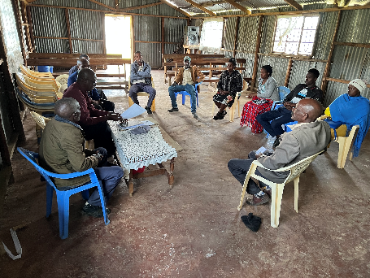
Figure 2: FGD with Ogiek VMG Members at Nassuit, Njoro, Nakuru County
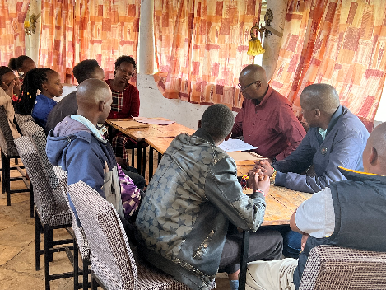
Figure 3: FGD with Masai VMG members in Maimahiu, Naivasha Sub-county, Nakuru County

3.2.3 Key Informant Interviews
- Key informant interviews were conducted with some of the VMG members especially the youth and people living with disabilities to delve in their interactions with the digital economy, the services they consumed, and the challenges encountered. Three key informants were interviewed, one from each of the sites namely Nassuit, Kongasis, and Mai-Mahiu. These were a teacher, businessman, and influential elder respectively.

Data Analysis
- The amount of qualitative data generated in this SA study was relatively small. Therefore, the qualitative data were analyzed manually through reading, re-reading, sorting and organizing the data around the emerging themes to address the objectives of the Social Assessment. Examples of the broad themes that emerged were around livelihood activities, project impacts, use of ICT services, and so on.

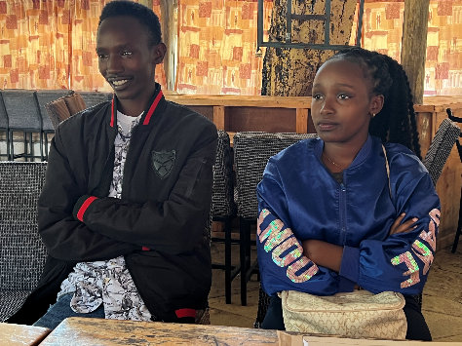
Figure 4: Youth Participants and Key Informants in Maimahiu, Naivasha Sub-county, Narok County.
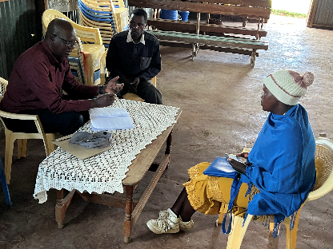
Figure 5: Consultation with Ogiek Members Living with Disabilities

4.0 Key Findings of the Social Assessment

4.1 Socio-economic Profile of the Study Area

4.1.1 Overview of Nakuru County Demographic Characteristics
- This section focuses on the socio-economic profile of Nakuru as a background to the VMGs that live in the county. According to the Nakuru CIDP (2018), the County is among the 14 Counties within the Rift Valley region. The major economic activities include; agriculture, tourism and financial services. Nakuru is an agricultural rich county whose background was shaped by the early white settlement schemes. The county human settlement has been shaped by major transport infrastructure i.e., early colonial rail network and road A104. The poverty level for the County is at 29.1 percent.

- According to the CIDP (2018) the County covers an area of approximately 7,498.8 Square Kilometers and is located between Longitudes 35.41° East or 35° 24’ 36” East and 36.6° East or 36°36’ 0” East and Latitude 0.23° North or 0° 13’ 48” North and 1.16° South or 1° 9`36” South. The County headquarters is Nakuru City. Nakuru Municipality was awarded a City Charter on December 1, 2021.

- The CIDP (2018) shows that the County has 11 sub-counties/constituencies namely; Naivasha, Nakuru Town West, Nakuru Town East, Kuresoi South, Kuresoi North, Molo, Rongai, Subukia, Njoro, Gilgil and Bahati. There are 55 wards in the County. Nakuru County is home to 2.1 Million people as per the Kenya National Bureau of Statistics (KNBS) projections for 2017. The County’s two major urban areas are; Nakuru City which is the County’s headquarters and Naivasha town which is popular for both local and international tourism because of its proximity Nairobi the capital city of Kenya. Nakuru and Naivasha towns are complemented by other urban centres spread across the County that include; Molo, Njoro, Gilgil, Mai Mahiu, Subukia, Salgaa and Rongai.

- The CIDP (2018) points out that the dominant communities include; Kikuyu and Kalenjin. Other communities present in the County include; Abagusii, Luo, Luhya, Maasai, Kamba, Meru among others. Not all these non-dominant communities are VMGs. The main VMGs are Masai, Turkana, and Samburu, who are traditionally pastoralists, and Ogiek who are traditionally hunter-gatherers.

4.1.2 Land Ownership and Landlessness
- Nakuru is historically a large-scale agricultural county having inherited the status from the colonial settlers who controlled most of the arable land. Nakuru County has few large-scale land owners holding approximately 263 Hectares (Ha) of land on average. On the other hand, the County is dotted with many small-scale land owners with mean landholding size of 0.77 Ha. The bulk of the land holdings in the county are small-scale and are found mainly in the high potential agricultural areas. The medium and large-scale farms account for a small per cent of the holdings but cover the largest area under farming. The mean holding size for land ownership in urban areas is 0.05 Ha.

- Nonetheless the CIDP (2018) points out that slightly less than 20 per cent of the households are considered to be landless. Some of these landless persons are 2007-8 Post Election Violence (PEV) Victims settled in camps for Internally Displaced Persons (IDPs), while others are informal settlement dwellers and immigrants either in employment or engaged in business activities. There are also incidences of landlessness affecting those who were evicted from the Mau Forest.

4.1.3 VMG Livelihoods and the Digital Economy

4.1.3.1 Ogiek of Nassuit, Marioshoni
- Marioshoni ward of Molo constituency is home to the largest proportion of Ogiek people in Kenya. The land they inhabit was forest land and has been cleared for settlement in the last twenty years. The Ogiek claim this land as their traditional territory as hunters and gatherers over several generations. However, this claim has been contested and a court case has progressed through Kenyan courts over the years and landed in the African Court on Human and People’s Rights where it was decided in favor of the Ogiek on May 26th, 2017. The African Court ruled inter alia that the Mau forests are the ancestral home of the Ogiek peoples and stated that the most salient feature of indigenous societies is their unhindered access to and use of their traditional land. Even after the court ruling however, the Ogiek continue to live on the land without title deeds.

- The Ogieks’ livelihoods revolve around bee keeping and honey. According to Kang’ethe, Ontita and Mwangi (2000) honey is critical to their religion and belief systems and is a central item in their rituals and ceremonies. They have placed beehives in the forests around them and on their farms. They sell the surplus honey through cooperatives and self-help groups. They also grow maize, beans, vegetables, and potatoes for domestic consumption and for sale of surpluses to the rest of the country through middlemen who transport it. The Ogiek rear dairy cattle and sell most of the milk in Njoro and Nakuru towns. Some of them conduct business activities in the trading centres in their territory and beyond.

- The Ogiek are a patriarchal society. They have a strong council of elders that holds sway in most community-wide decisions. All members of the council are men, but women participate in local community meetings and contribute to discussions without hindrance. Other representative organizations of the Ogiek include churches, self-help groups organized around honey production and sales, the NGO Ogiek Peoples Development Program (OPDP) and several Community-Based Organizations (CBOs).

4.1.3.1.1 Ogiek Participation in the Digital Economy
- The Ogiek FGD participants reported that they accessed internet or digital services mainly through mobile phone service providers especially Safaricom. Other mobile service providers the Ogiek used to access internet are Telkom and Airtel. They complained of high costs involved in accessing internet through the mobile service providers.

- The Ogiek men and women usually do not use the internet as much as the youth did. They said that as an age-group they were not as comprehensively aware of the internet as the youth. They said Ogiek youth reported that they access internet using their smartphones which are not very common in the area. They mainly access it for entertainment in YouTube, WhatsApp and TikTok. Those in college said they access internet for their lessons through Zoom, Google Classroom, and other similar platforms.

- A teacher in FGD and in a key informant interview said that it was common for her and colleagues to search for information on the internet to supplement textbooks in teaching and learning at their work places. They pointed out that while some schools in the area had received computers and tablets from the Ministry of Education, internet could not be accessed in the schools because accessing it using mobile service providers was expensive and not covered by government.

- Overall, the FGD members pointed out that the gadgets such as tablets, smartphones and computers that were necessary in accessing the digital economy were too expensive for them. Also, the mobile internet service was weak, intermittent, and the services too expensive. Additionally, awareness of and training on the digital economy was very low in the Ogiek Territory.

- The FGD participants and key informants supported the KDEAP and recommended that the KDEAP training and mentorship on the Digital Economy for the Ogiek Youth. They said that there were some unemployed youth, who had recently graduated from universities and middle-level colleges who need training, mentorship, and employment in the project and the digital economy including online jobs. They said a community center with internet connection at Marioshoni or Nassuit provided by KDEAP will help the youth gain better access and participation in the Digital Economy. They expressed fear that the KDEAP benefits would be hijacked by youth and professionals from the dominant communities in the county to the Ogiek exclusion.

- The FGD participants and key informants said that project information directed at the Ogiek should be channeled through the Ogiek Council of Elders, the Ogiek Development Program (ODP), and the Ogiek FM Radio Station, Soogot FM that broadcasts from Marioshoni. They stated that if those channels are not used, they will not receive the information.

4.1.3.2 The Maai-Mahiu Masai
- The Maai-Mahiu Area is in Naivasha Sub-county of Nakuru County. This sub-county borders Narok County to the south-east and east, and Narok County is predominantly occupied by the Masai People. Therefore, the Masai in Maai-mahiu are in a contiguous traditional Masai Territory that spreads from Kajiado through Narok into Nakuru County.

- In Maai-Mahiu the Masai people practice nomadic pastoralism as the main means of livelihood. They move their livestock seasonally into Narok and Kajiado counties in the east and into Nyandarua and Laikipia counties in the north in search of pasture and water. Nonetheless, in Maai-Mahiu they own private land where they have built their permanent homes to which they return with their livestock when pasture and water is available.

- The Masai supplement their livestock economy with sand and building stone harvesting and trade. They have local groups that supply sand and ballast to construction sites. In the Masai villages in the two areas, herbalists practice traditional medicine. They fetch medicinal herbs from different forests and prepare them at home. In good seasons the Masai grow maize, beans, vegetables, and other horticultural crops such as bananas, onions, and tomatoes to supplement their income and improve food security.

- There were a few people in the areas that were involved in livestock trade. They buy livestock in the villages and transport in lorries to Nairobi where they sell at a profit. Some bought livestock locally, slaughtered in Suswa or Maai-Mahiu slaughterhouses and supply meat to hotels in Nakuru and Nairobi.

- In the villages women were involved in caring for small stock such as calves, goats, and sheep. Besides, they made ornamental beads for the market. Buyers visited the villages to buy and sell in the highways in the rest of the country or export to the western world where Masai attires and souvenirs sell at good prices.

- The Masai are a patriarchal society where property is inherited by male children from their fathers. Women and girls have few economic chances because they do not own land or cattle, which must belong to men. Their economic and political power are thus largely limited. Nonetheless, change is occurring in a few areas because of women succeeding formal education. So, there are Masai women teachers, nurses, lawyers, and politicians, although the numbers are low relative to their population size in the country.

- Traditionally men wield a lot of political and economic power. They are organized in age-sets based on year of circumcision. Each age-set has a chief that is widely respected by his agemates across Masai-land beyond his village and county of residence. There are elders who traditionally control events including migration, going to war and peace agreements with neighboring ethnic groups and enemy clans. The elder are the custodians of indigenous knowledge and its practice. Reference is made to them in planning rituals and ceremonies.

4.1.3.2.1 The Maai-Mahiu Masai and the Digital Economy
- The FGD participants and key informants said they accessed internet through mobile service providers Safaricom, Airtel, and Telkom. They said men and women did not use the internet much due to lack of gadgets and knowledge on the uses of internet.

- The youth were the main participants in the digital economy. The youth reported that they used the internet for research, studies, communication, and entertainment including sports, betting, and gambling.

- A teacher key informant said that he and some of his colleagues accessed internet for learning and teaching materials. He said that some primary schools had been supplied with tablets and computers but had no internet connections and thus the gadgets were used offline. Local secondary schools had no computers and no internet connections, while some local colleges had Wi-Fi connections in the campuses. The students suffered expensive and slow connections while out of the campuses. Local secondary school teachers used the expensive mobile internet to access teaching materials mainly revision materials online.

- All FGD participants and key informants said that mobile money transfer services were widely used among members of VMGs. This aspect had changed the manner in which money was handled and made financial transactions easier and convenient. They said that even fund raiser events were conducted online and realized more money than before mobile was introduced and at lower organizational cost.

- They further pointed out that the KDEAP was a good project and was unlikely to negatively affect the VMGs, except for fences, kiosks other temporary business structures along the roads where fiber optic cables will be laid, but this they acknowledged will be temporary and rare. They urged that where such were affected compensation be provided to the owners.

- They supported the KDEAP and recommended that training and mentorship be offered by the KDEAP to local youth, businesspersons, and teachers. They also welcomed the project idea of linking local schools to fiber optic cables for faster and cheaper internet for educational purposes. They said that at community level there was need for community centers with internet connections. It was argued that the best way to reach them with project information was through their council of elders, age-set chiefs, and local administrators.

4.1.3.3 Masai, Samburu and Turkana of Kongasis, Ol Jorai
- Ol Jorai is in Elmentaita Ward, Gilgil Constituency. The Masai of Ol Jorai have lived in the area from time immemorial. The name of the place is from the Maa language. The Samburu and Turkana on the other arrived in Ol Jorai around 1992. Previously they worked and lived in farms in Solai and the Agricultural Development Corporation (ADC) farms in Nakuru County. In 1992 some of them bought land in Ol Jorai Settlement Scheme and settled there. Some became squatters in the private farms in the area. Therefore, while most of these people have title to the land, others have been squatters for over twenty years and are marginalized.

- In terms of livelihoods, the Masai, Samburu and Turkana follow their traditions of rearing livestock including sheep, goats, and cattle. Nonetheless, they also grow maize, beans, peas, potatoes, vegetables, and fruits. They sell surpluses in the market for an income. Their children attend local schools and some travel to access education in Nakuru Town. The people also run businesses in local market centers such as Ol Jorai and Kongasis. These businesses include grocery shops, hardware shops and mobile cash transfer shops.

4.1.3.3.1 Masai, Samburu and Turkana of Kongasis, Ol Jorai and the Digital Economy
- The FGD participants and key informants said that men and women used the internet very rarely because they did not have the right gadgets such as smartphones. For those adults that had smartphones they mainly accessed the internet to use WhatsApp in church and community-based organizations (CBO) forums. A teacher key informant said that he and his colleagues accessed internet as a source of information for teaching and learning.

- The Youth said they accessed internet through local mobile service providers and used it for entertainment on WhatsApp, YouTube, Facebook and TikTok. Some of them said they used the platforms to advertise their music and it was earning them an income. One youth said that he had bought a motorbike online from GG OLX without any challenges. He said that buying online enabled him to compare prices and ultimately buy on the most competitive price. They said that they welcomed affordable and improved connectivity through the KDEAP in their territory.

- They said that the main challenges they faced in accessing and utilizing internet was prohibitive cost of access, low internet speeds, limited training, and limited awareness of opportunities in the larger digital economy. Besides, local schools and TVET colleges did not have access to internet. They said that in the unlikely event that any of their properties along the roads or footpaths where fiber optic cables will be laid is affected, they welcome compensation.

- They recommended that local youth and teachers be trained on IT skills and the digital economy, a community center with free internet be set up exclusively for the VMG youth, and the cost of accessing internet in the homes be reduced to improve usage.

4.1.4 Impact of COVID-19 on VMGs
- Participants of focus group discussions (FGDs) and Key informant said that their lives and livelihood activities had been affected by COVID-19 in different ways. They said that at the height of the pandemic in 2020/21 they were unable to sell their produce including honey, livestock, and livestock products such as meat, milk, hides and skins, agricultural produce including vegetables, potatoes, maize, and beans. This is because movement of people and goods was very low during the pandemic. When their children were sent back home and asked to learn online the cost of connecting to the internet was high and the network weak and intermittent. They said that children in VMG areas suffered more than their counterparts in better connected areas with better economies. The participants said that having internet in the schools and communities through the KDEAP will help their children access learning online like other children around the country.

4.2 Policy, Institutional and Legal Frameworks
- The rights of the VMG are anchored in the Constitution of Kenya (CoK) and in several institutions; these include Commissions, Ministry of Labor and Social Protection; Ministry of Public Service, Youth and Gender Affairs. These Ministries, Departments and Agencies (MDAs) are responsible for promoting and coordinating efforts around empowerment for the youth, women and people living with disabilities (PLWDs) in the country, while also ensuring gender equity.

- The National Gender and Equality Commission is responsible for mainstreaming issues related to minorities and marginalized groups while the National Cohesion and Integration Commission is responsible for preventing discrimination on the basis of race, ethnicity or other considerations and promoting cohesion among the many and diverse groups in the country.

- The Constitution of Kenya (CoK) recognizes the socio-economic and cultural rights of all citizens as stipulated in Article 43. Article 21 requires State organs and public officers to address the needs of vulnerable groups within society including women, older members of society, persons with disabilities, members of minority or marginalized groups, and members of particular ethnic, religious or cultural communities that are deemed historically excluded. It identifies marginalized communities as:
- a community that because of their relatively small population or for any other reason, has been unable to fully participate and fully integrate into the larger social and economic life of Kenya.
- a traditional community that, out of a need or desire to preserve its unique culture and identity from assimilation, has remained outside of and thus failed to integrate into the larger social and economic life of Kenya.
- an indigenous community that has retained and maintained a traditional lifestyle and livelihood based on a hunter or gatherer economy; or
- pastoralist persons and communities, whether they are—(i) Nomadic; or (ii) A settled community that, because of its relative geographic isolation, has experienced only marginal participation in the integrated social and economic life of Kenya as a whole.

- The aforementioned definition is in line with provisions of ESS 7 in the World Bank ESF. Like ESS 7 the definition covers historical disadvantage, protection of identity and culture, and unique livelihoods most dependent in large measure on natural resources. Based on this recognition of marginalization in Kenya, the country has developed a number of policies and created institutions to address the special need of VMGs in the country.

- In addition to the legal and institutional framework, there are some policy guidelines and documents, which are relevant to the development and welfare of the VMG:
- Kenya Vision 2030: has been designed to transform Kenya into a middle-income country by the year 2030. It has three pillars – economic, social, and political, of which the social and the economic pillars are the most relevant for the purpose of this report. The social pillar aims to “build a just and cohesive society with social equity in a clean and secure environment”. It, therefore, presents comprehensive social interventions aimed at improving the quality of life of all Kenyans and Kenyan residents. This strategy makes special provisions for Kenyans with various disabilities (PWDs) and previously marginalized communities. The economic pillar aims at improving the prosperity of all Kenyans through an economic development program, covering all the regions of Kenya. It aims to achieve an average Gross Domestic Product (GDP) growth rate of 10% per annum beginning in 2012.

- National Social Protection Policy: developed in 2011, this policy is aimed at reducing poverty and the vulnerability of the population to economic, social, and natural shocks and stresses. The main objectives of the policy include; (i) protecting individuals and households from the impact of adverse shocks to their consumption that is capable of pushing them into poverty or into deeper poverty; and (ii) cushioning workers and their dependents from the consequences of income-threatening risks such as sickness, poor health, and injuries at work as well as from the threat of poverty in their post-employment life.

- National Land Policy: though Kenya does not have a clearly defined or codified land policy, the 2009 version envisages the treatment of all people equitably, addressing itself to the various categories of VMGs including children, youth, pastoralists and minorities. In order to secure access to land and land-based resources for vulnerable groups generally, the policy proposes to a) develop mechanisms for identifying, monitoring and assessing the vulnerable groups; (b) establish mechanisms for redistribution of land and resettlement; (c) facilitate their participation in decision making over land and land-based resources; and (d) protect their land rights from unjust and illegal expropriation.

- Gender Policy, 2011 – this policy guarantees equality of men and women before the law in accessing economic and employment opportunities. It facilitates the review of laws that hinder women’s access to and control over economic resources and improve vocational and technical skills of disadvantaged groups, notably unemployed youth, disabled women, poor urban and rural women, and street dwellers, for improved access to employment opportunities.

- It should be noted that all the polices including the Kenya Vision 2030 speaks to both the financial protection and the value chain component since the focus is on building resilience of the vulnerable and marginalized groups in the drylands of Kenya.

4.3 Stakeholder and Institutional Analysis
- This section identifies the various actors that have stakes in the socio-economic and political lives of the various VMGs and explains how those stakes play out and how such might be useful to the KDEAP Project.

4.3.1 Farmers’ Groups
- In Nassuit and Kongasis areas the Ogiek and Masai, Samburu, and Turkana farmers had many farmers’ groups. The groups formed the major avenues for accessing agriculture extension services, farm inputs such as fertilizers, aggregating produce such as potatoes and maize, and sales. The leaderships were informal and chosen through consensus. In some instances, group members shared seed and agricultural knowledge and practices among themselves. They also shared information on prevailing prices and the best times to sell their produce. These groups were identified in FGDs and by Key Informants as primary stakeholders in the KDEAP as they potentially would form a major information conduit for members. Besides, the farmers’ groups are potential users of and actors in the emerging digital economy.

4.3.2 Cooperative Societies
- The Ogiek had cooperative societies that brought them together as beekeepers and honey producers. The cooperatives were formally registered with the Ministry of Cooperatives and often enjoyed training by Cooperative Officers from the National Government. The functions of the cooperatives included beekeeping and honey production, aggregation of honey, honey processing and packaging, warehousing, marketing, and banking members’ returns. The leaderships were formal and in compliance with the Cooperatives Act. The Masai of Mai-mahiu also had cooperatives organized around sand harvesting and sales. These cooperatives organized labor for harvesting, loading and selling on behalf of members. They thus linked the members to the banks. Hence, FGD participants and key informants saw them as critical stakeholders in the KDEAP as actors in the digital economy accessing market information, financial services and education through the internet. The cooperatives were mentioned by FGD participants as possible ICT hubs to benefit VMGs.

4.3.3 Pastoralist Groups
- The focus group discussions revealed that the Masai, Samburu, and Turkana had formed groups for the furtherance of their pastoralist livelihoods. Even those that were involved in business activities were also members of these groups that they used to market their livestock and to even take care of them. Therefore, the main functions of the groups include livestock production and marketing, dairy production, small-scale business, some crop production, and charitable activities such as gift exchange. The groups were mainly led by men who were chosen once and replaced after death or in very old age. These groups could form a major information channel for the KDEAP as per FGD participants.

4.3.4 County Government
- The County Government was identified as a key stakeholder with potential extensive influence on the KDEAP. The County Government stakeholders include relevant line ministers who will have a significant role to play in this project and therefore must be engaged and consulted throughout the project phases. These include those responsible for ICT, education, licensing and enforcement departments in the County Government because they dealt with emerging small businesses such as cyber cafes on a day-to-day basis. Veterinary services are devolved and were thus offered by county government hence the latter’s influence and contact with pastoralist groups that identified the county government as critical to their livelihoods including livestock and meat trade. The Veterinary Departments at the counties would therefore be a good channel of KDEAP information to the pastoralist groups.

4.3.5 National Government
- The participants in the FGDs identified the National Government as a stakeholder in their livelihoods especially in terms of security provided by the Ministry of Interior and Coordination of national Government. The Ministry of Cooperatives was also identified as critical to the various cooperative societies that operated in VMG territories. Overall, the KDEAP would need to engage with national government officers in the counties in the course of project implementation.

4.3.6 Indigenous Leaderships
- Key informants and FGD participants identified various indigenous leaderships as critical to information dissemination, conflict resolution, and social change initiatives in VMG areas. These included the Ogiek Council of Elders, the Masai Age-set Chiefs/Leaders, Samburu and Turkana Village Elders. The various FGD participants pointed out that the leaders were influential would be useful in shaping the respective VMG’s perceptions and attitudes towards the KDEAP and thus engaging with them continuously will lead to widespread acceptance and ground the project in the territories.

4.3.7 Civil Society Organizations
- As VMGs the Ogiek, Masai, Turkana, and Samburu had NGOs that spoke for them. The Ogiek had an NGO called Ogiek People’s Development Program (OPDP) that coordinates their affairs. The Masai, Samburu, and Turkana had the Pastoralists Development Network (PDN) that speaks for all pastoralists in the country. The FGD participants identified these two NGOs as their umbrella organizations that should be engaged along-side other groups during the KDEAP implementation.

4.3.8 Teachers’ Associations and Unions
- The teachers in the VMG territories are primary stakeholders in the KDEAP since the fiber optic cables will terminate in the school. The schools, both primary and secondary will be hosting project service users including learners and teachers will organize the usage. They will require mass training before they guide participation in learning processes in schools and in the digital economy in the villages as well. The teachers will be engaged directly in VMG territory schools and through associations such Kenya Primary School Heads Association (KEPSHA) and Kenya Secondary Schools Heads Association (KESSHA), as well as teachers’ unions Kenya National Union of Teachers (KNUT) and Kenya Union of Post Primary Education Teachers (KUPPET). The latter will lead project consultation to TVET institutions in the VMG territories as well.

5.0 Potential Positive and Negative Impacts of the KDEAP

5.1 Potential Positive Impacts
- Consultations in the FGDs and with key informants revealed that there was some participation in the digital economy that the project will enhance. For example, across the VMGs territories the youth were using internet for learning and entertainment. In some instances, the youth were posting their music on the net as a way of advertising it. In one case among the VMGs in Ol Jorai a youth had sourced and successfully purchased a motor bike online. However, the participation in the digital economy faced several challenges. These included weak and intermittent networks from a few vendors which were too expensive to access. Most of the VMG members also did not have adequate and appropriate gadgets to use in accessing and effectively participating in the digital economy. Additionally, training and awareness on the digital economy was low.

- Nonetheless, the participants identified the following as potential positive impacts of the KDEAP:
- Improved access to learning and teaching materials for VMG learners
- Access to weather information for better farming
- Increased online business leading better returns and value for money
- Reduce carbon emissions because with stable and affordable internet connections fewer people will travel for meetings or classes away from home or even to visit cyber cafes in towns.
- Access to online jobs will reduce unemployment and poverty in the VMG territories.

- Overall, the MSME participants consulted argued that the KDEAP would contribute to improved and expanded livelihoods in the VMG areas with better returns and inclusion of VMGs in the digital economy. This is also expected to spur diversification of livelihoods into online business and value addition of local produce due to better online markets leading to stable income and food security. In particular, pastoralist group members hoped to market their livestock and meat online and deliver more livestock products to markets outside their territories due to connection to the digital economy.

5.2 Potential Negative Impacts
- The potential negative impacts of the KDEAP include (1) exclusion of the VMGs from the project. This is likely to result from the VMGs’ current limited access to ICT equipment and internet services, inadequate awareness and inadequate on computing and the digital economy. Therefore, if specific measures are not made to include VMG members including students and youth in the project, exclusion is inevitable. Further mitigation measures suggested by FGD participants include mentorship and training of VMG youth on computing and online jobs as well as the digital economy as a whole. (2) in the event that internet connections improve through the KDEAP there is a likelihood that small businesses such as cyber cafes and online jobs will flourish in those isolated VMG areas and crime may set in due emerging inequality. FGD participants and key informants said that this negative impact will be mitigated through close working relationships with the representatives of the Ministry of Interior such as the chiefs and police officers to counter criminals. (3) During KDEAP implementation, trenching may affect roadside business structures, fences, trees, and services such as water pipes and electricity lines. The FGD participants said that this negative impact will be mitigated through compensation for affected assets and facilitation or timely relocation of services before trenching begins. (4) Trenches for laying the fiber optic cables unless managed properly will pose safety challenges for humans and livestock. This will be mitigated through effective warning signs, barricades, and effective backfilling.

6.0 Enhancement of Potential KDEAP Benefits For VMGs
- The potential benefits of the KDEAP will require further actions for their effective realization by the VMGs. This is because the VMGs have limited awareness, training and skills, equipment, and related business to handle digital economy services in their territories. For those reasons the following actions will be required to enhance the VMGs’ chances at enjoying the potential benefits:

- Awareness creation around computing, online jobs, and digital economy opportunities in general. Some VMG youth were accessing internet on their smart phones mainly for entertainment. They need to be moved beyond entertainment to identifying digital economy opportunities.
- To utilize digital economy opportunities members of VMGs require training and capacity development on computing and other knowledge and skillsets necessary for their effective participation in the digital economy.
- After training and capacity development the VMG youth will require mentorship from seasoned digital economy actors. This will help entrench them in the digital economy, benefit, and mentor others in their communities to work and do business in the emerging economy.
- Since there are no cyber cafes in the shopping centres in VMG territories it will be appropriate for the KDEAP to support the establishment of community centres with Wi-Fi to support VMG youth and other interested people gain experience and skills to start cybercafé business as demand for services outstrip the capacity of the community centres.
- KDEAP will enhance benefits for VMGs school children if the project supports provision of IT equipment to schools in their territories. This will give VMG children a head-start in gaining computing skills, accessing learning and teaching materials online and ultimately getting ready for the digital economy.

7.0 Capacity Building and Institutional Strengthening
- Capacity building is an ongoing, gradually developed process in the project that takes place at all levels from the community to the project management units at state and national levels.

- In all Bank-assisted projects, capacity building is an ongoing process taking place at different levels from the participating community members and institutions up to the National Project Implementation Unit (PIU). Some examples of capacity building and institutional strengthening required in the KDEAP are elaborated as follows.

- At the Community level training of the indigenous leaderships, cooperative society leaders, school boards of management, pastoralist group leaders, farmers’ group leaders and civil society leaders is important, including on subjects such as organizational strengthening including running meetings and record keeping, financial management, development of action plans, social action, accountability, and empowerment. KDEAP could work with institutions such CELARS at University of Nairobi to provide training and capacity building for grassroots organizations.

- Project Staff. The Project Management teams at the Ministry of Information, Communication, Technology and Digital Economy, and at the ICT Authority including the KDEAP PIU need to be sensitized especially to social issues such as inclusion, gender, diversity, VMGs, social sustainability and other aspects of social development. The CELARS at the University of Nairobi specializes in this kind of services for development projects.

- Other Stakeholders. Capacity building of project partners including departments of education, departments of health and health institutions, NGOs, and other stakeholders needs to cover social inclusion, including sensitization to gender, diversity, VMGs, livelihoods of the poor, etc. Training government departments should help them understand their roles vis a vis the project and digital economy promotion and help them to provide the relevant technical and advisory services.

- Successful capacity building strategies are normally contextualized. Assessment of capacity gaps at all levels is an important first step. For example, some critical capacity gaps at VMG level include low knowledge of computing, ICT, and digital economy opportunities, and how to manage them, inadequate knowledge and practice of social accountability, and proper governance of various institutions including indigenous leadership organizations, pastoralist groups, cooperatives and farmers’ groups. Among these local institutions capacity gaps include limited ability to plan productive investments, inadequate knowledge of online marketing, purchases and trade, low capacity to maintain regular accounts, exclusion of the poorest and vulnerable, and so on.

- The success of capacity building efforts depend essentially on ensuring linkages and a balance at all project levels, as well as continuous development and reinforcement of capacities. Even training to include the poorest of the poor requires continuous effort, particularly if inclusion is to be mainstreamed and practiced widely in the project. Methods and contents of capacity building need to be robust and innovative to address these issues. The whole capacity building portfolio needs to take an adaptive management perspective and training partners have to be familiar with problem-based methods of training to be effective in these mainly informal situations.

8.0 Grievance Redress Mechanism
- Grievances can arise right at any time and at any level in the project. A grievance is a concern or complaint raised by an individual or group affected by the project. The concerns and complaints can result from either real or imagined impacts of the project. This GRM therefore, provides guidance, guidelines and modalities for managing grievances that may emerge from KDEAP implementation process. It also provides modalities for raising awareness, visibility, and understanding on KDEAP and providing feedback on its implementation.

- The KDEAP GRM offers project stakeholders and VMGs an opportunity to seek and receive grievance/ complaints and strengthen the project team to identify, track, resolve and refer eligible grievances thereby enhancing KDEAP efficiency and development of outcomes.

- This KDEAP GRM is being anchored in the existing local conflict/grievance resolution structures in the GRM territories. Among all the VMGs FGD participants said that whenever they had grievances about government projects, they approached the chief and if not satisfied report to the County Commissioner or their deputy. The Masai and Samburu FGD participants said that when they had disputes among themselves, they used their age-set chiefs and if not satisfied went to the councils of elders that were settlement based comprising of the Village Chairman and village elders. The Turkana FGD participants reported that they have a council of elders that handles their disputes.

- The KDEAP GRM will be guided by the following principles.

- Promptness - grievances usually relate to the welfare of complainants and should be resolved as quickly and completely as possible. Time is of essence in this GRM process.

- Transparency - the GRM system and process will be as open as possible. No deals should be struck under the table. GRM process outcomes should as much as possible be disclosed to VMGs to build confidence in the system.

- Fair and Effective - the system should be fair, treating the same issues in the same manner regardless of who the complainant is. Committees involved should aim to deal with matters comprehensively and to the satisfaction of parties.

- Non-retributive to complainant - the system should ensure that complainants are protected throughout the process and project. They should not suffer any loss or injury from the contractor or VMG community merely for raising their complaint with the GRM system. This assurance should be the preamble of any grievance process.

- Appropriateness to Custom - this GRM strives to conclude the resolution of grievances at the lowest level of the mechanism namely, the council. This relates to the kind of dispute resolution process that VMG members are familiar with, and which they consider simple and fair. The process up the ladder is complex and alien and may not be considered fair.

- Documentation - the grievances or feedback will be recorded as received and the resolution process and outcomes will be documented judiciously. The aim is to keep record just in case the same grievances are mischievously raised up the GRM ladder and for learning purposes.

- Each VMG preferred to have grievance mechanisms organized around their territories. In this line of thought there will be grievance committees at Maaimahiu, Nassuit, and Ol Jorai. These committees will handle issues in conjunction with the project and if not resolved escalate them to the sub-county level where the Assistant County Commissioner’s (ACC) committee will take over. The ACC’s Committee brings together the ACC, Contractor, and proponent’s grievance experts. From the ACC’s committee the grievance would be escalated to the National Ombudsman. At every point the complainant will be free to exit the mechanism and seek judicial intervention. The schematic version of the GRM is presented below.

Document
An aggrieved party reports a grievance, and it is recorded
Resolved & Closed: Exit

Document
Resolved & Closed: Exit
The Council hears and rules on the matter within 14 days.

Document
Resolved & Closed: Exit
ACC’s Committee hears the matter and rules within 14 days

Document
Resolved & Closed: Exit
Ombudsman - CAJ hears the matter

Resolved & Closed: Exit
Matter is left for legal/court action
Document

- The VMG’s Council that will hear a grievance in the first instance will be composed of the following.
- Chair of Council of Elders (Chair)
- Two (2) women
- Two male members
- One youth
- Local Chief/Assistant Chief
- Contractor’s Social Safeguards Person (Secretary)

- The ACC’s committee will include the following.
- The ACC (Chair)
- Local Chief
- Chair of the Council of Elders / Representative
- A Woman representative of the VMG concerned
- Contractor’s Social Safeguards Person
- Proponent’s Social Safeguards Person (Secretary)

- The ombudsman (Commission for Administration of Justice) has her own procedures for receiving and processing grievances. The same applies to the judicial system. The contractor will be obligated to continually disclose this GRM to the VMGs and to sensitize them to its principles and how the process works.

9.0. Conclusions
- The findings of the social assessment reveal that there exist limited usage of the internet and participation in the digital economy in VMG areas where the Ogiek, Masai, Samburu, and Turkana people live in Nakuru County. The youth used internet for entertainment, studies, and in a few cases for advertising their music. Some of the youth had also bought items online. A few of the VMG members that used internet accessed it through mobile service providers and they reckoned network access was unaffordable, weak, intermittent, and unavailable in some parts of VMG territories.

- These VMG livelihoods were negatively affected during the height of the COVID-19 pandemic in 2020/21. Businesses did not access stock during lockdown periods. Farmers and pastoralists alike did not access markets due to limited movement of people from their homes. A robust digital reach to the VMG areas would have more positive impacts for livelihoods during a pandemic.

- It was also established through the social assessment that there is scope for the KDEAP to provide fiber optic cable to schools and other institutions, but to also establish community centers with WIFI to spur the digital economy in the VMG areas. Among the Ogiek for instance, there is scope to use the internet connections to enhance honey marketing beyond traditional local markets. Among the Masai, Turkana and Samburu participation in the digital economy is expected to contribute to the expansion of meat and livestock businesses and markets beyond local butchery shops to increasing volumes shipped to urban areas and abroad.

- The potential negative impacts of the KDEAP such as exclusion or further marginalization of the VMGs from the digital economy and ICT infrastructure and use, can be mitigated through concerted information provision and awareness creation on the KDEAP and its services in the VMG territories. Therefore, the KDEAP has potential to influence livelihood diversification in online jobs and businesses and alleviate poverty in VMG areas.

- In the area of education, the KDEAP is set to contribute to improved access to online learning and teaching materials for learners and teachers in the VMG areas. This is likely to increase VMG children’s participation in education and alleviate exclusion of VMGs in the sector.

References

GoK (2010) Constitution of Kenya. Nairobi: Government Printers.

Nakuru County (2018) County Integrated Development Plan 2018 – 2022. Nakuru: County Government of Nakuru.

Nakuru County (2020) Nakuru County Annual Development Plan. Nakuru: Nakuru County Government.

Kang’ethe L., E. Ontita and E. Mwangi (2000) Forestry and Food Security in Kenya: The Case of South-West Mau Forest. Nairobi: Forest Action Network.

Annexes

Annex 1: Attendance Sheet for the Nassuit FGD for Ogiek People
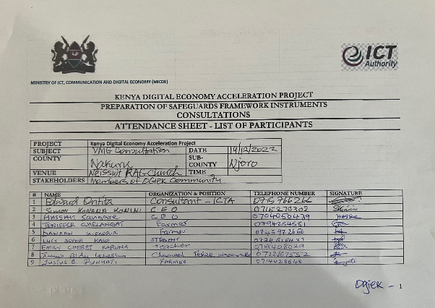

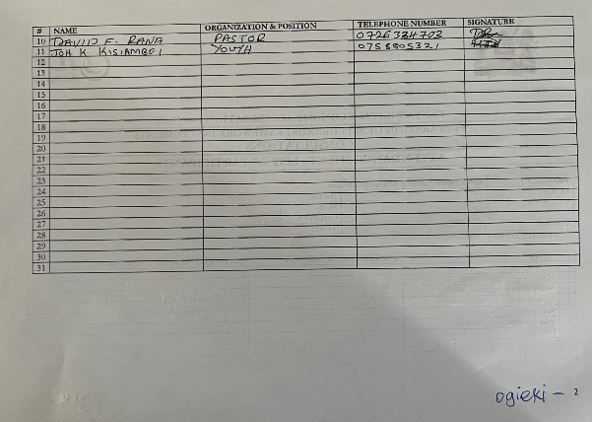

Annex 2: Attendance Sheet for the Mai Mahiu Masai FGD
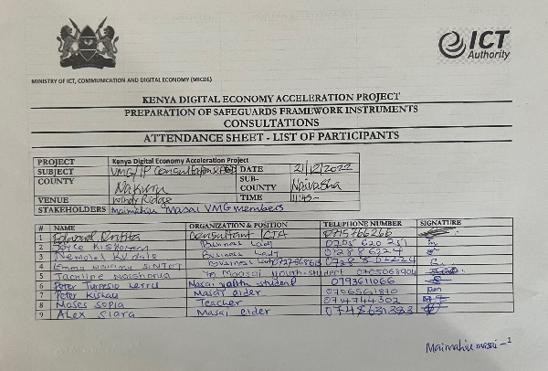

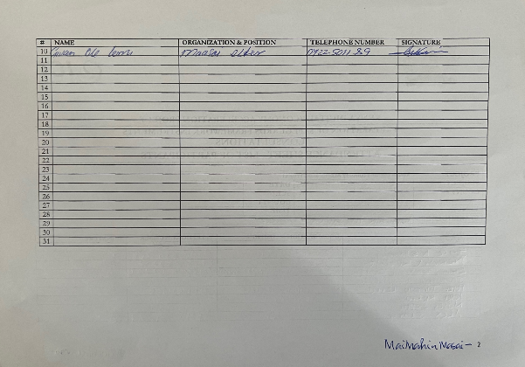

Annex 3: Attendance Sheet for the FGD of Ol Jorai VMGs
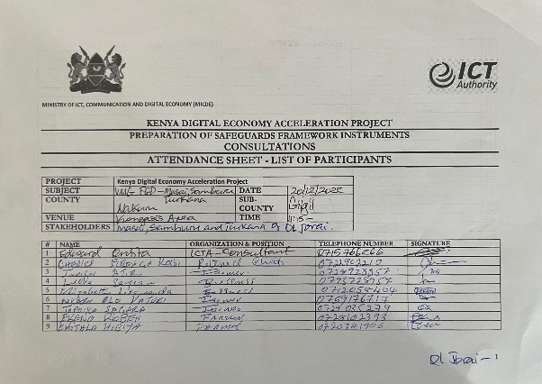

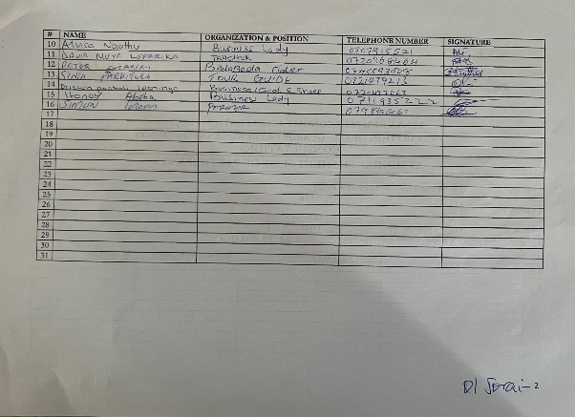

Annex 4: LIST OF PEOPLE LIVING WITH DISABILITIES CONSULTED

# | Name | Gender | VMG
1. | Justus Punyati | Male | Ogiek
2. | Jennifer Chelangat | Female | Ogiek

Annex 5: List of Key Informants Interviewed
# | Name | Occupation/Community Role | VMG Area
1 | John Kiplangat | Teacher | Ogiek Area
2 | Sapit ole Moloi | Businessman | Mai-Mahiu Masai
3 | Lokiru Moru | Elder | Kongais Turkana

Annex 6: FGD Guide

Ministry of ICT, Communication and Digital Economy (MICDE)

KENYA DIGITAL ECONOMY ACCELERATION PROJECT (KDEAP)
FOCUS GROUP DISCUSSION GUIDE

Preliminaries
- Prayer by a volunteer
- Introductions
- Brief on the KDEAP

Focus Group Discussion Themes
- What are the main sources of livelihood in this area? Probe for sources of income, food, social support and protection.
- What are the main socio-economic and cultural characteristics of the (specific VMGs) in this area? Probe for specific IP characteristics.
- What is your current digital connectivity? Do you have access to the internet? How do you as (specific VMG) people access internet in this area? How do women, men, youth respectively use internet services? Would you welcome improved digital connectivity?
- What are the challenges that you face in accessing and using internet in this area?
- Do your children in primary, secondary, and tertiary institutions have access to internet services? If yes, where do they access those services? What challenges do they face and how do they overcome them?
- The KDEAP will require the construction of digital infrastructure to increase digital connectivity. Would you have any concerns that natural habitats could be affected by construction? Or that the environment could be impacted? Or that any of your livelihoods could be impacted?
- What will be the benefits of the KDEAP to the (specific VMG) people? How can these benefits be enhanced for the (specific VMG) people?
- Which adverse impacts do you foresee from the KDEAP? How can those be mitigated? By whom?
- How best can the fiber optic cables be laid to schools and health facilities without causing any harm to the (specific VMG) people?
- Have you ever bought or sold anything online? What challenges did you face and how did you overcome them? Probe the youth for online jobs.
- Who are the main stakeholders in the KDEAP in this area? Probe for role of County Governments, Telecoms, Financial Institutions, National Governments, Farmers /Pastoralists /beekeepers.
- If you have a general grievance about a government project, where do you turn for redress?
- The project will implement a grievance redress mechanism, what in your opinion, are the best ways to allow stakeholders to file a grievance?
- We would like to keep you informed about the project, what is the best way to disseminate information to you?
- Any further comments?

Thanks for your participation in this discussion

Annex 7: Key Informant Interview Guide

Ministry of ICT, Communication and Digital Economy (MICDE)

KENYA DIGITAL ECONOMY ACCELERATION PROJECT (KDEAP)
KEY INFORMANT INTERVIEW GUIDE

Introduction and brief on the KDEAP

1. What are the main sources of livelihood in this area?

2. What are the main socio-economic and cultural characteristics of the (specific VMGs) in this area? Probe for specific IP characteristics.

3. What is your current digital connectivity? Do you have access to the internet? How do you as (specific VMG) people access internet in this area? How do women, men, youth respectively use internet services? Would you welcome improved digital connectivity?

4. What are the challenges that you face in accessing and using internet in this area?

5. Do (VMG) learners in primary, secondary, and tertiary institutions have access to internet services? Where do they access those services? What challenges do they face and how do they overcome them?

6. The KDEAP will require the construction of digital infrastructure to increase digital connectivity. Would you have any concerns that natural habitats could be affected by construction? Or that the environment could be impacted? Or that any of your livelihoods could be impacted?

7. What will be the benefits of the KDEAP to the (specific VMG) people? How can these benefits be enhanced for the (specific VMG) people?

8. Which adverse impacts do you foresee from the KDEAP? How can those be mitigated? By whom?

9. How best can the fibre optic cables be laid to schools and health facilities without causing any harm to the (specific VMG) people?

11. Who are the main stakeholders in the KDEAP in this area? Probe for role of County Governments, Telecoms, Financial Institutions, National Governments, Farmers /Pastoralists /beekeepers.

12. If you have a general grievance about a government project, where do you turn for redress?
13. The KDEAP Project will implement a grievance redress mechanism, what in your opinion, are the best ways to allow stakeholders to file a grievance?

14. What are the best ways to disseminate information to members of this VMG community?

15. Any further comments on the KDEAP?

Thanks for your participation in this interview

